Day 2 Snack
Pretzel Teepees

Introduction for the Station Leader:
Good morning! I hope you had an enjoyable day yesterday. Now here we are on Day 2. Today’s theme is God protects us. This theme is shown throughout many Bible stories, but today we are learning about Shadrach, Meshach, and Abednego and the Fiery Furnace. These three men get thrown into the furnace for not bowing down to the statue that King Nebuchadnezzar created. The men survive because a fourth man, Jesus, appears and protects them from the fire. The men come out unharmed.
This theme is also shown in the West. In the West, there are dangers at every corner: rattlesnakes, wolves, coyotes. Not to mention the weather can be very dangerous with terrible storms and tornadoes. Despite all these hardships, the settlers are protected by each other and by God. Even today God continues to protect us.
One of the most well known icons of the West is the Native American Teepees. A teepee is a type of shelter that was used by Native Americans. It protected them from the elements. Therefore, it is perfect for today’s theme. Today’s teepee snack will be made out of marshmallows, pretzel sticks, and fruit roll ups.
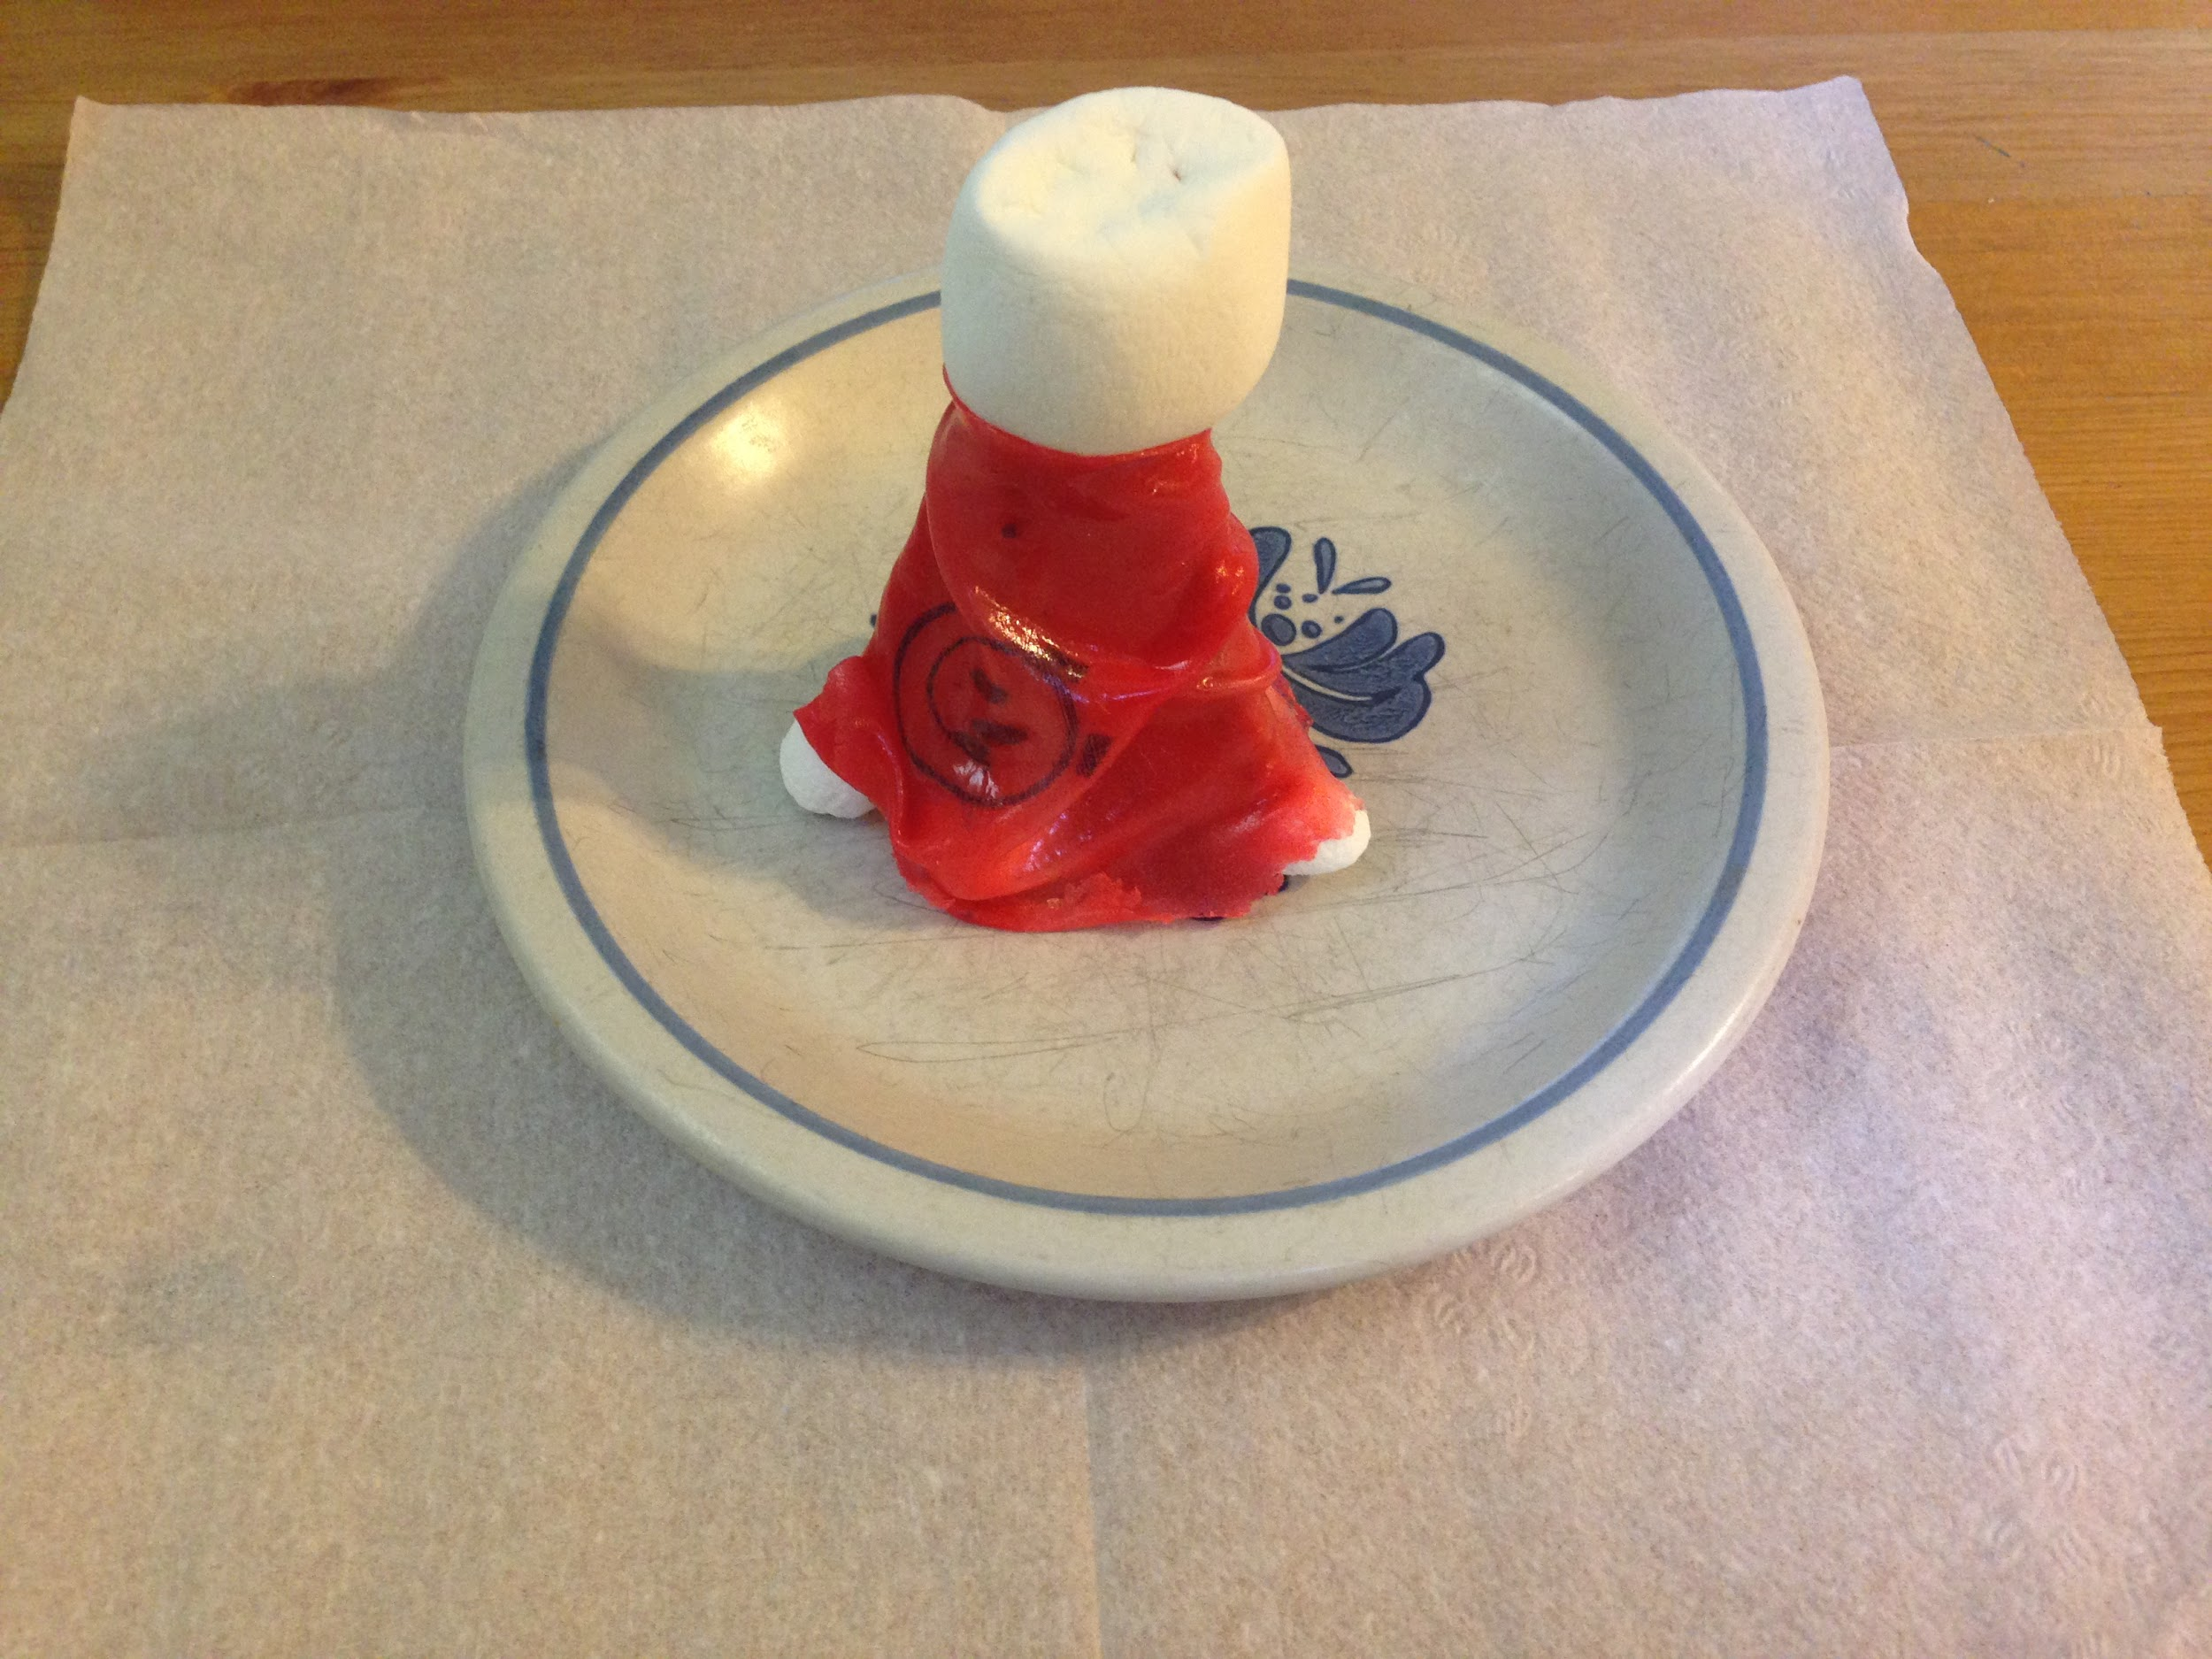
Supplies:
- Regular Marshmallows
- Mini Marshmallows
- Fruit Roll ups
- Pretzel Sticks
- Plates
- Cups
- Juice
- Water
- Napkins

How to Make the Snack:
You will need 1 large marshmallow, 6 mini marshmallows, 6 pretzel sticks, and 1 fruit rollup. Take the large marshmallow and 6 pretzel sticks. Stick one end of each of the pretzels into the marshmallow so they are all sticking up. Then take the 6 mini marshmallows and stick them on the other end of the pretzels. Flip the whole thing over so the mini marshmallow end of the pretzels are on the plate. Take a fruit roll up, and wrap it around the pretzels. There are two different kinds of fruit roll ups so wrapping them are slightly different. Done!

Note:
You will have to modify the snacks if there is an allergy.

Preparation:
- Have all the ingredients for each teepee on a plate so they can be handed out easily

Instructions for when the group arrives:
- Welcome them back to another day of VBS
- Explain what the snack is today
  - Marshmallow and pretzel stick teepee with fruit rollups
- Briefly explain how the teepee protected Native Americans
- Get them their drinks
  - Juice (you pour)
  - Water (you pour)
- Hand out a plate to each child with all ingredients and napkin
- Tell them these steps in order and help them if they need it:
  - Take the large marshmallow and 6 pretzel sticks
  - Stick one end of each of the pretzels into the marshmallow so they are all sticking up
  - Then take the 6 mini marshmallows and stick them on the other end of the pretzels
  - Flip the whole thing over so the mini marshmallow end of the pretzels are on the plate.
  - Take a fruit roll up, and wrap it around the pretzels.
- Let them eat!
- This is a time for socialization
  - Get the children to socialize with each other as they eat their snack
- When they are done eating, have them throw out their garbage, and wash their hands

Cleanup:
- At the end of each group please:
  - Make sure all garbage is off the table
  - Clean up any big messes
- At the end of each day please:
  - Clean up all garbage
  - Wipe down the table and counter
  - Sweep the kitchen and under the table

