Day 2 Elementary Craft
Fiery Furnace

Introduction for the Station Leader:
Good morning! I hope you had an enjoyable day yesterday. Now here we are on Day 2. Today’s theme is God protects us. This theme is shown throughout many Bible stories, but today we are learning about Shadrach, Meshach, and Abednego and the Fiery Furnace. These three men get thrown into the furnace for not bowing down to the statue that King Nebuchadnezzar created. The men survive because a fourth man, Jesus, appears and protects them from the fire. The men come out unharmed.
This theme is also shown in the West. In the West, there are dangers at every corner: rattlesnakes, wolves, coyotes. Not to mention the weather can be very dangerous with terrible storms and tornadoes. Despite all these hardships, the settlers are protected by each other and by God. Even today God continues to protect us.
Today’s craft shows today’s Bible Story. It is a “stain glass” hanging fiery furnace with Shadrach, Meshach, Abednego, and Jesus inside. I put “stain glass” in quotes because it is not stain glass. It is paper with tissue paper glued on top of it. This is the children’s version of stained glass. This should make for a great project!

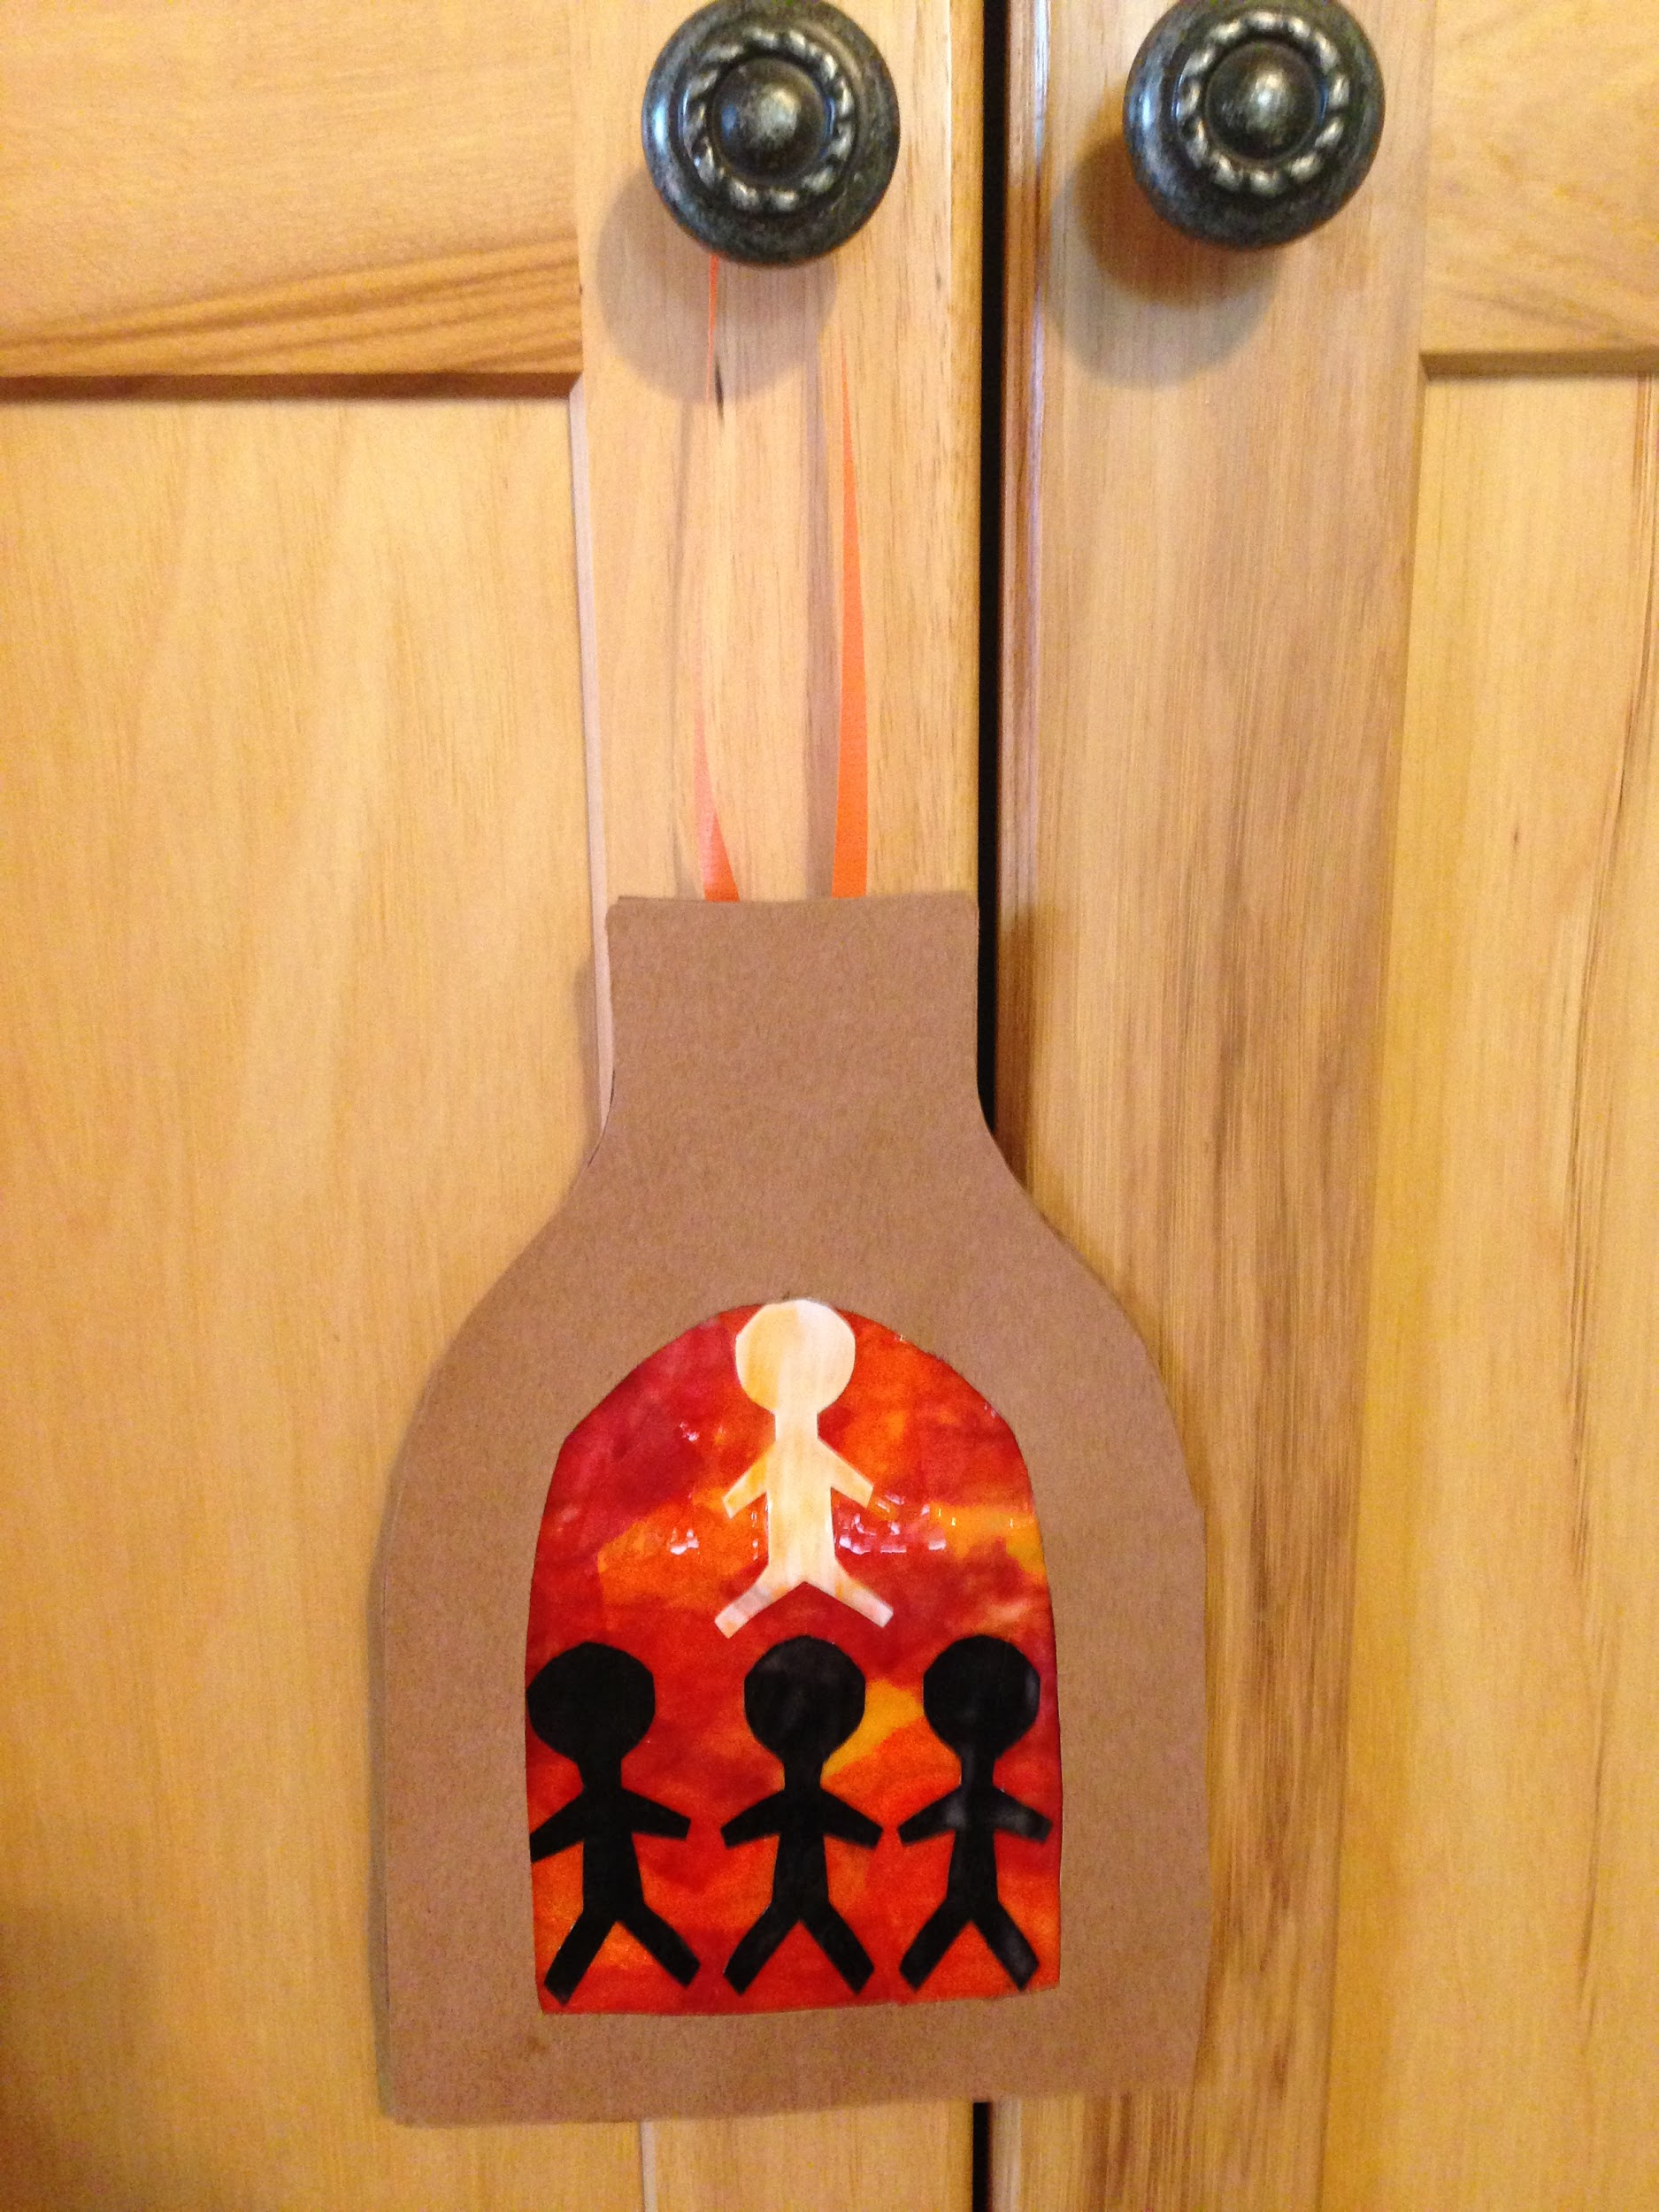
Supplies:
- White Construction Paper
- Black Construction Paper
- Brown Construction Paper
- Wax Paper (precut)
- Glue
- Paintbrushes
- Containers
- Ribbon
- Tissue Paper (Red, orange, and yellow)
- Scotch Tape
- Newspaper
- Sharpies
- Furnace Template

How to create the Fiery Furnace:
Take a furnace template and cut out the back and the front. Separate them Take a piece of ribbon and tape both ends to the top like a handle. Take a precut piece of wax paper and tape it onto the back of the furnace. Cut out four silhouettes, three black and one white. Take a paintbrush and glue and paint the glue onto the wax paper. Put tissue paper onto the glue and paint over it as you go. Then take four silhouettes, one white and three black, and put them onto the wax paper. Paint over them as well. Paint the edges of the furnace with glue and put the other half on top, making sure it lines up with the bottom. Set aside to dry.

Preparation:
- Have the precut waxed paper out
- Have the templates on the table
- Mix up the glue
  - Pour the glue into containers and mix with a little water to make a thinner mixture
- Lay down newspaper at every seat
- Set up a drying station

Instructions for when the group arrives:
- Welcome the group back to another day of VBS
- Explain the craft that they will be making today and show the sample that is provided
- Ask them what the theme is for the day (God protects us)
  - They might not know or remember the theme yet so if they don’t get it, please remind them
- Then tell them briefly how God and Jesus protected Shadrach, Meshach, and Abednego in the fiery furnace.
  - Again, some groups may not have gone to Bible Story yet. Please just give a brief explanation of this
- Hand them a furnace template and have them cut out and separate the back and the front.
- Have them write their names on the back of the furnace
- Have them take a piece of ribbon and tape both ends to the top like a handle
- Have them take a precut piece of wax paper and tape it onto the back of the furnace
- Have them cut out four silhouettes, three black and one white
- Let them take a paintbrush and glue and paint the glue onto the wax paper
- Immediately after, have them put tissue paper onto the glue and paint over it as they go
- Let them take four silhouettes, one white and three black, and put them onto the wax paper, and paint over them as well
- Have them paint the edges of the furnace with glue and put the other half on top, making sure it lines up with the bottom.
- Set aside to dry
.
Cleanup:
- At the end of the day please:
  - Clean up all glue and their containers
  - Clean up or put away supplies you don’t need for the rest of the week
  - Throw away garbage and used newspaper
  - Wipe down the table
  - Wash out paintbrushes thoroughly

