Day 1 Elementary Craft
Glass Jar Lantern

Introduction for the Station Leader:
Good morning! I wanted to start out by telling you the overall themes for the day and why we are creating lanterns. The main theme for the day is God guides us. This is shown through the Bible Story in Exodus. In Exodus, the Israelites are being led out of Egypt by Moses and God. God guides them by a pillar of cloud by day and a pillar of fire by night. God sent His Son, Jesus, to guide us and Jesus guides us through His word. God continues to guide us today.
Back in history, as settlers were traveling out west in the hopes of a better life, the settlers were not going into the prairies and deserts blind. They were led by a guidebook or a guide, who was an experienced man who had traveled the route many times. This is the connection from the West to the overall theme.
Why are we creating lanterns on Day 1? That is simply answered because it was used both by the early settlers of the West and the Israelites. In order to see at night, the settlers had lanterns. The Israelites also had lanterns, but these were oil lamps. The idea of fire also connects to the Bible Story of the day. God led the Israelites out of Egypt with a pillar of cloud by day and a pillar of fire by night. In order to show this fact to the children, we will be creating lanterns.

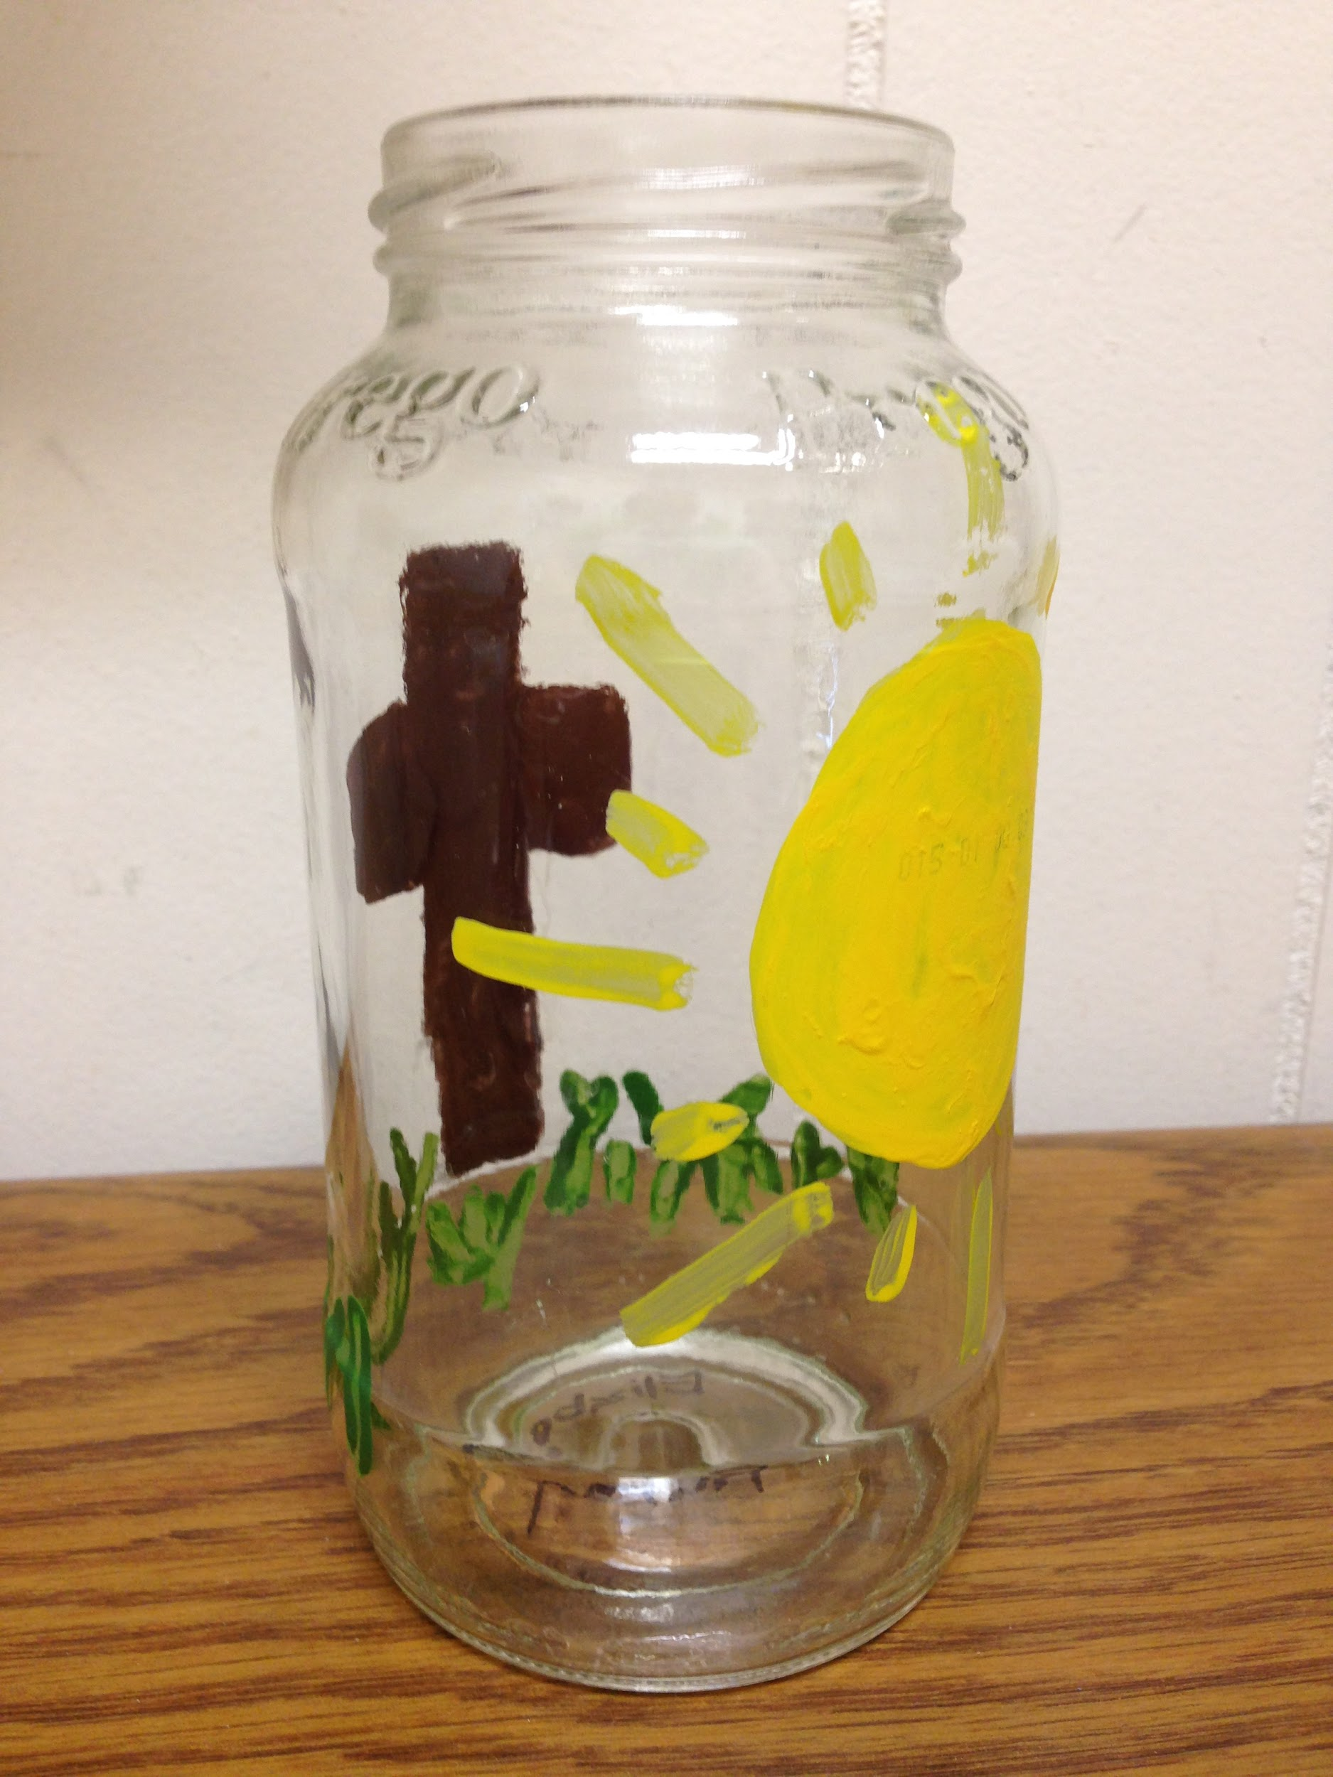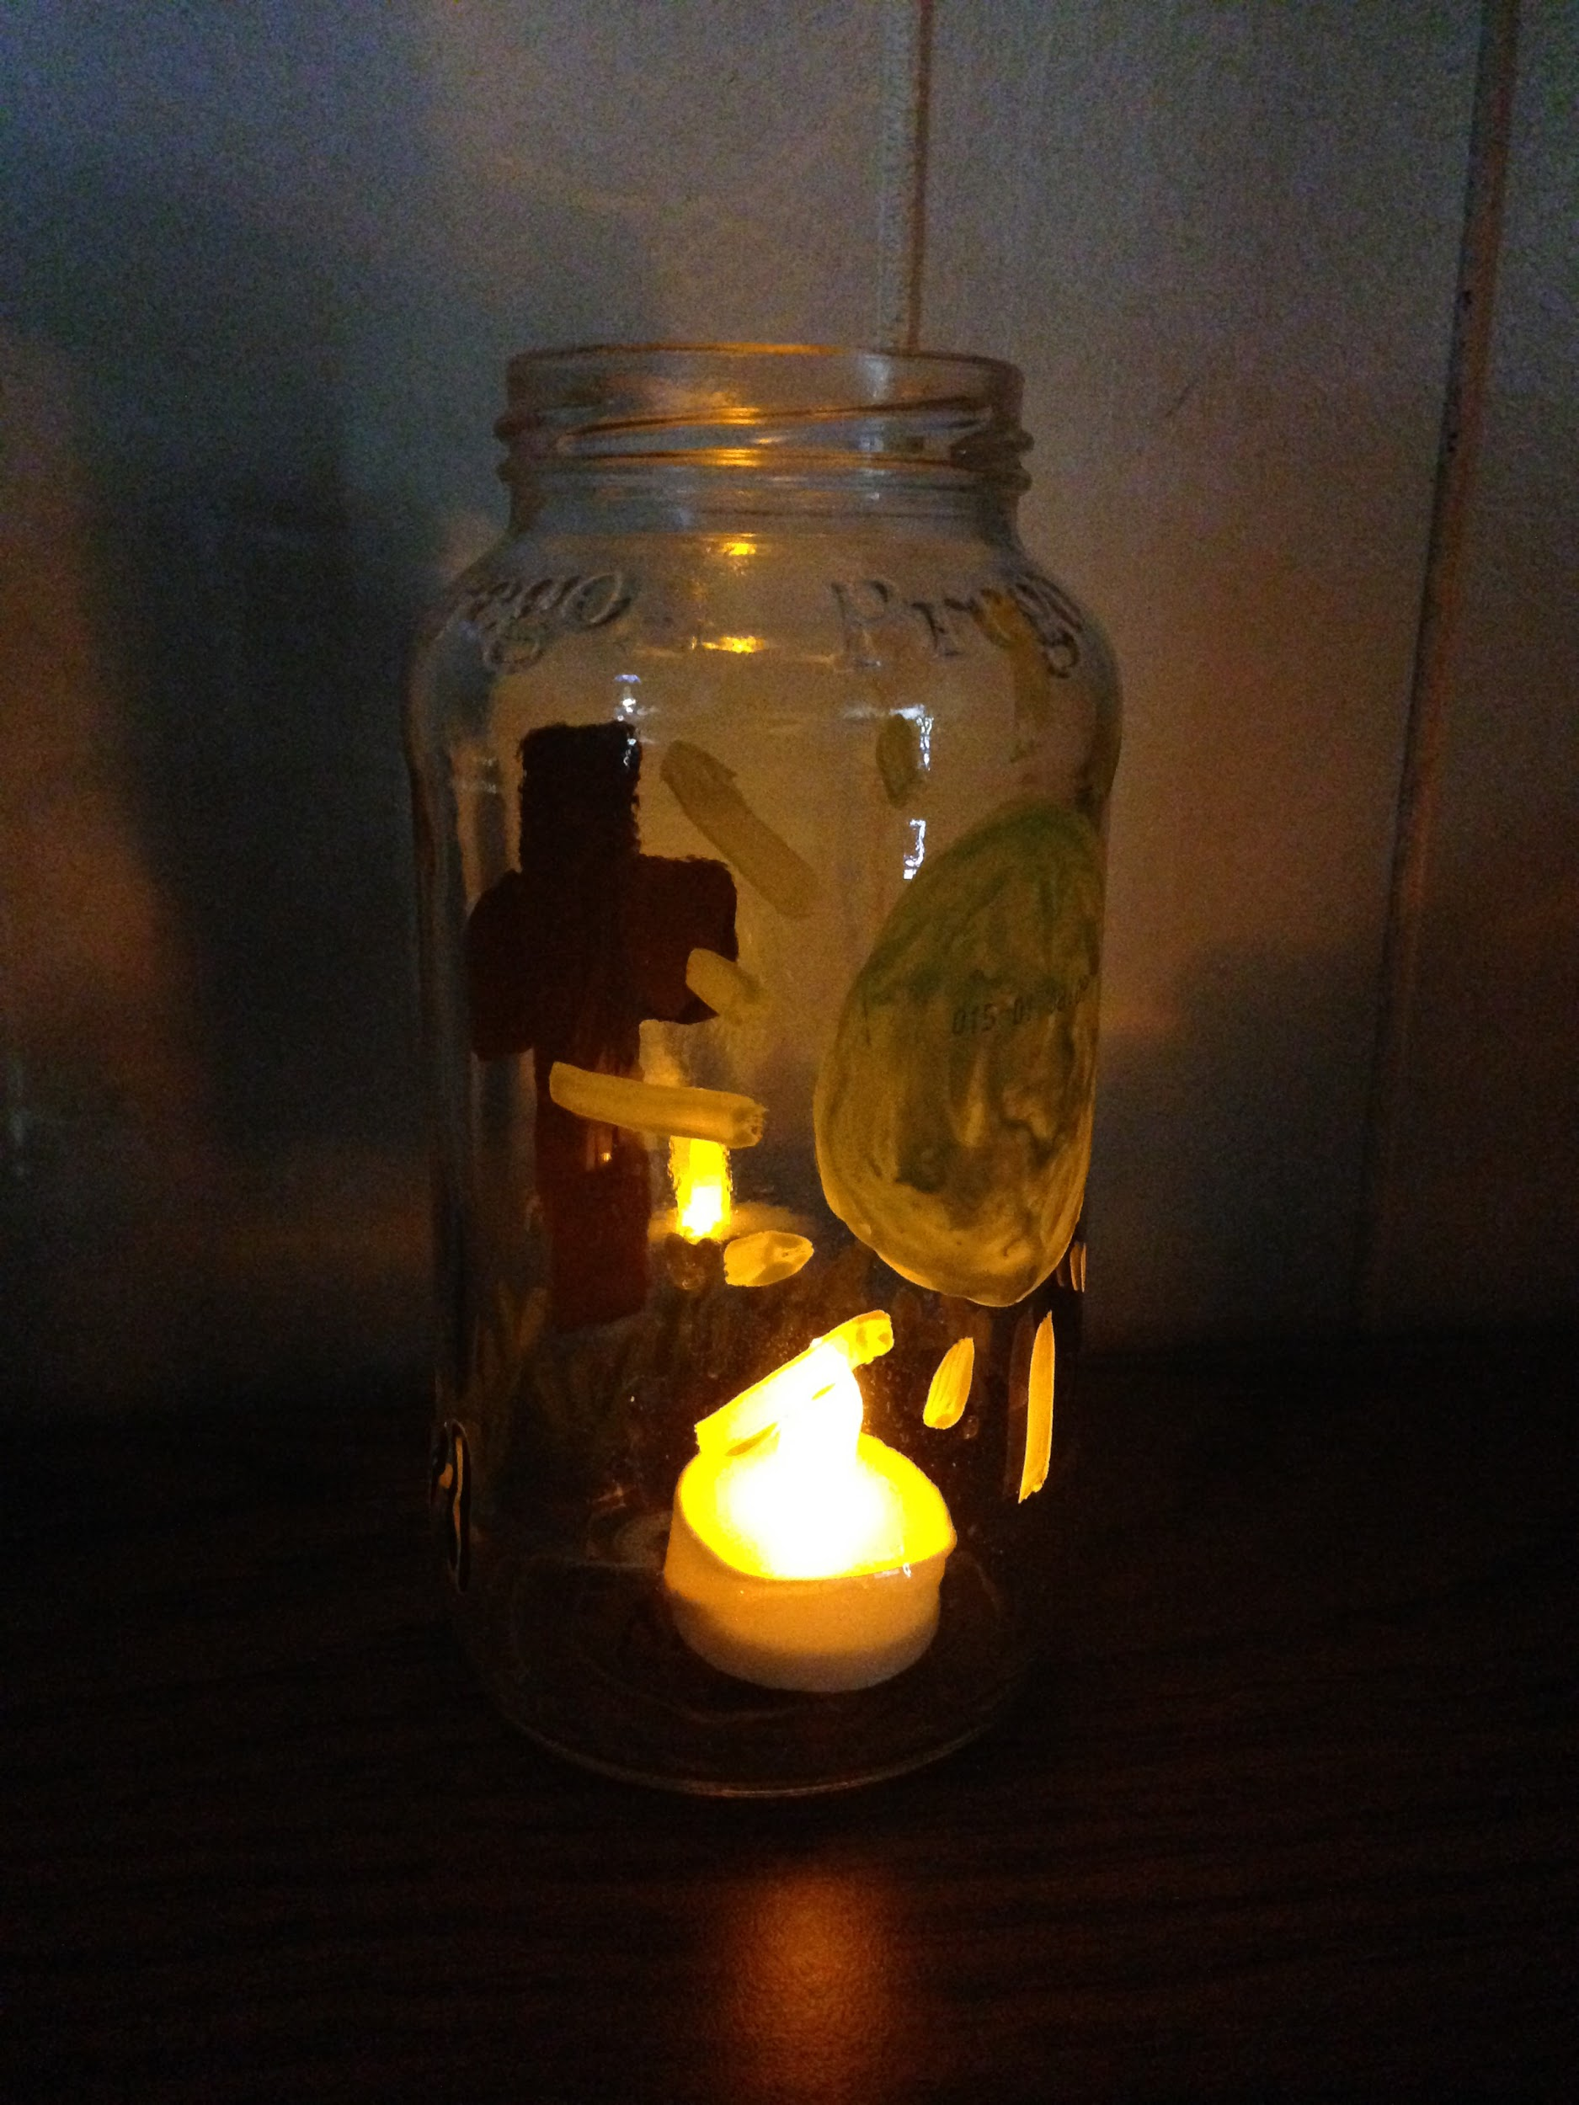

Supplies:
- Glass Jar (one per child)
- Paintbrushes
- Paint
- Sharpies
- Battery-operated tealights
- Newspaper
- Containers (for the paint)

How to create the lantern:
Take a glass jar and paint on it. Set it aside to dry. You do not need to keep the lid.

Preparation:
- Have containers filled with different kinds of paint on the table
- Have paintbrushes on the table
- Set up a drying station with newspaper
- At each chair, put a piece of newspaper for them to paint the jar on

Instructions for when the group arrives:
- Welcome the group and introduce yourself to them
- Explain the craft that they will be creating today and show the sample that is provided
- Ask them what the theme is for the day (God guides us)
  - They might not know or remember the theme yet so if they don’t get it, please remind them
- Then tell them briefly how God guided the Israelites out of Egypt with fire and how early settlers of the West used lanterns.
  - Again, some groups may not have gone to Bible Story yet. Please just give a brief explanation of this.
- Hand each child a glass jar and a Sharpie
- Have them write their names (first and last) on the bottom of their jar
- Let them paint the jar
- As they are done, have them put the jars on the drying station
- Have them wash their hands
- Take the battery-operated tealights and put one in each jar
Cleanup:
- At the end of the day please:
  - Throw away all the used newspapers
  - Wash out or throw out the containers of paint
    - Washing or throwing depends on what kind of containers you use
  - Wash all the brushes thoroughly
  - Wipe down the table
  - Clean up or put away supplies you don’t need for the rest of the week

