Day 5 Preschool Craft
Holy Spirit Dove

Introduction for Station Leader:
Good morning! It sure has been an exciting week. We all hope that you have had just as fun this week as the children had. We have learned so much, and it isn’t quite done yet! The theme of today and the last theme of the week is God empowers us. After Jesus dies on the cross and is resurrected from the dead, He appears to His disciples. He tells them that God will send them something. As the disciples are hiding, God sends them the Holy Spirit. This empowers them to spread the Word of the Lord to the world.
The settlers who came to the West came with practically nothing. They had some items and resources provided for them, but mostly, they didn’t have anything. They had to do everything for themselves. Many of the people in the West were some type of entrepreneurs. There were the farmers and ranchers and blacksmiths and masons and so much more! They were empowered. They had the power to do everything for themselves. God empowers us and the people of the West were also empowered.
Today’s craft has to do with Pentecost. The disciples were given the Holy Spirit by God. The Holy Spirit appeared as flames. When Jesus was baptised, a dove appeared, and God spoke about Jesus. This craft has a dove with flames hanging off its wings. This represents God giving the Holy Spirit to the disciples. By being a hanging decoration, it can be put anywhere in the house and shows that God empowers everyone with the Holy Spirit. This craft is fun and a great closer for the last day of VBS!
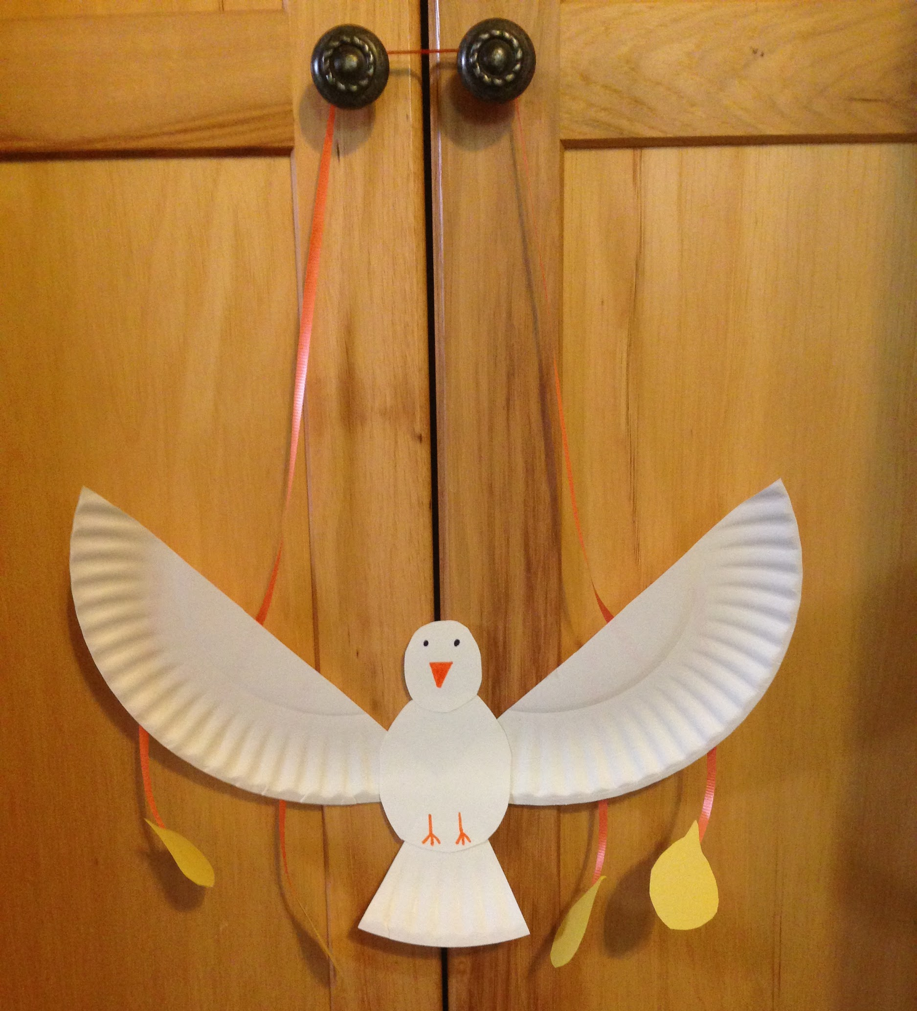

Supplies:
- Scissors
- White Paper Plates (dove)
- Scotch Tape
- Glue Sticks
- Yellow Construction Paper (flames)
- Ribbon
- Markers
- Containers

How to create the dove:
Take a head, body, and tail piece of the paper plate. Glue the three together. Draw on the eyes, beak, and feet with whatever color then set aside. Take four yellow flames and four pieces of ribbon. Tape one piece on each flame and then tape the other end of each ribbon onto the back of the wings. Glue the wings onto the body. Take one last long piece of ribbon and tape both ends to the separate wings to make a hanger. Done!

Preparation:
- Have the flames, ribbon, and paper plates already cut and put into the different containers
- Set up a drying station

Instructions for when the group arrives:
- Welcome the group to the last day of VBS
- Explain the craft that they will be creating today and show the sample that is provided
- Ask them what the theme is for the day (God empowers us)
  - They might not know or remember the theme yet so if they don’t get it, please remind them
- Then tell them briefly how God gave the Holy Spirit to the disciples.
  - Again, some groups may not have gone to Bible Story yet. Please just give a brief explanation of this.
- Hand out the head, body, tail, and wings of the dove
- Have them write their names on the back of the body
- Have and help them glue the head, body, and tail together
- Let them color on the eyes, beak, and feet
- Have them take four flames with ribbons attached and tape them onto the back of the wings
- Let them glue the wings on the body
- Take one last long piece of ribbon and have them tape it onto both wings to make a hanger
- Put it aside to dry

Cleanup:
- At the end of the day please:
  - Put away all supplies
  - Throw away all garbage
  - Sweep the floor
  - Wash down the tables

