Day 4 Preschool Craft
Cross

Introduction for the Station Leader:
Hello again! Welcome back! We are already on Day 4 of VBS. Today’s theme is God forgives us. This is shown through today’s Bible stories. The children will be covering two stories today. The Bible stories are the Passion and the Resurrection. Jesus dies on the cross to forgive our sins, and on the third day, He rises from the dead. These stories demonstrate that God forgives us.
When people rode out West, they usually rode out in a group. Also, when the people finally settled, they lived in small towns. In both these situations, the people only had who was around them to rely on. Also, many times there would be disagreements which is what happens with any group of people. The settlers had to learn to forgive each other so they could work together to survive. Forgiveness helped them start a new life.
Today’s craft illustrates the Passion of Jesus Christ. The most iconic symbol of the Passion is the cross. The craft today is a cross on paper made with tape and chalk. You’ll understand when it is explained further down. This is a very fun and easy craft to do that uses some materials and techniques that some may have never thought of doing before. It is a reminder that God forgives us.

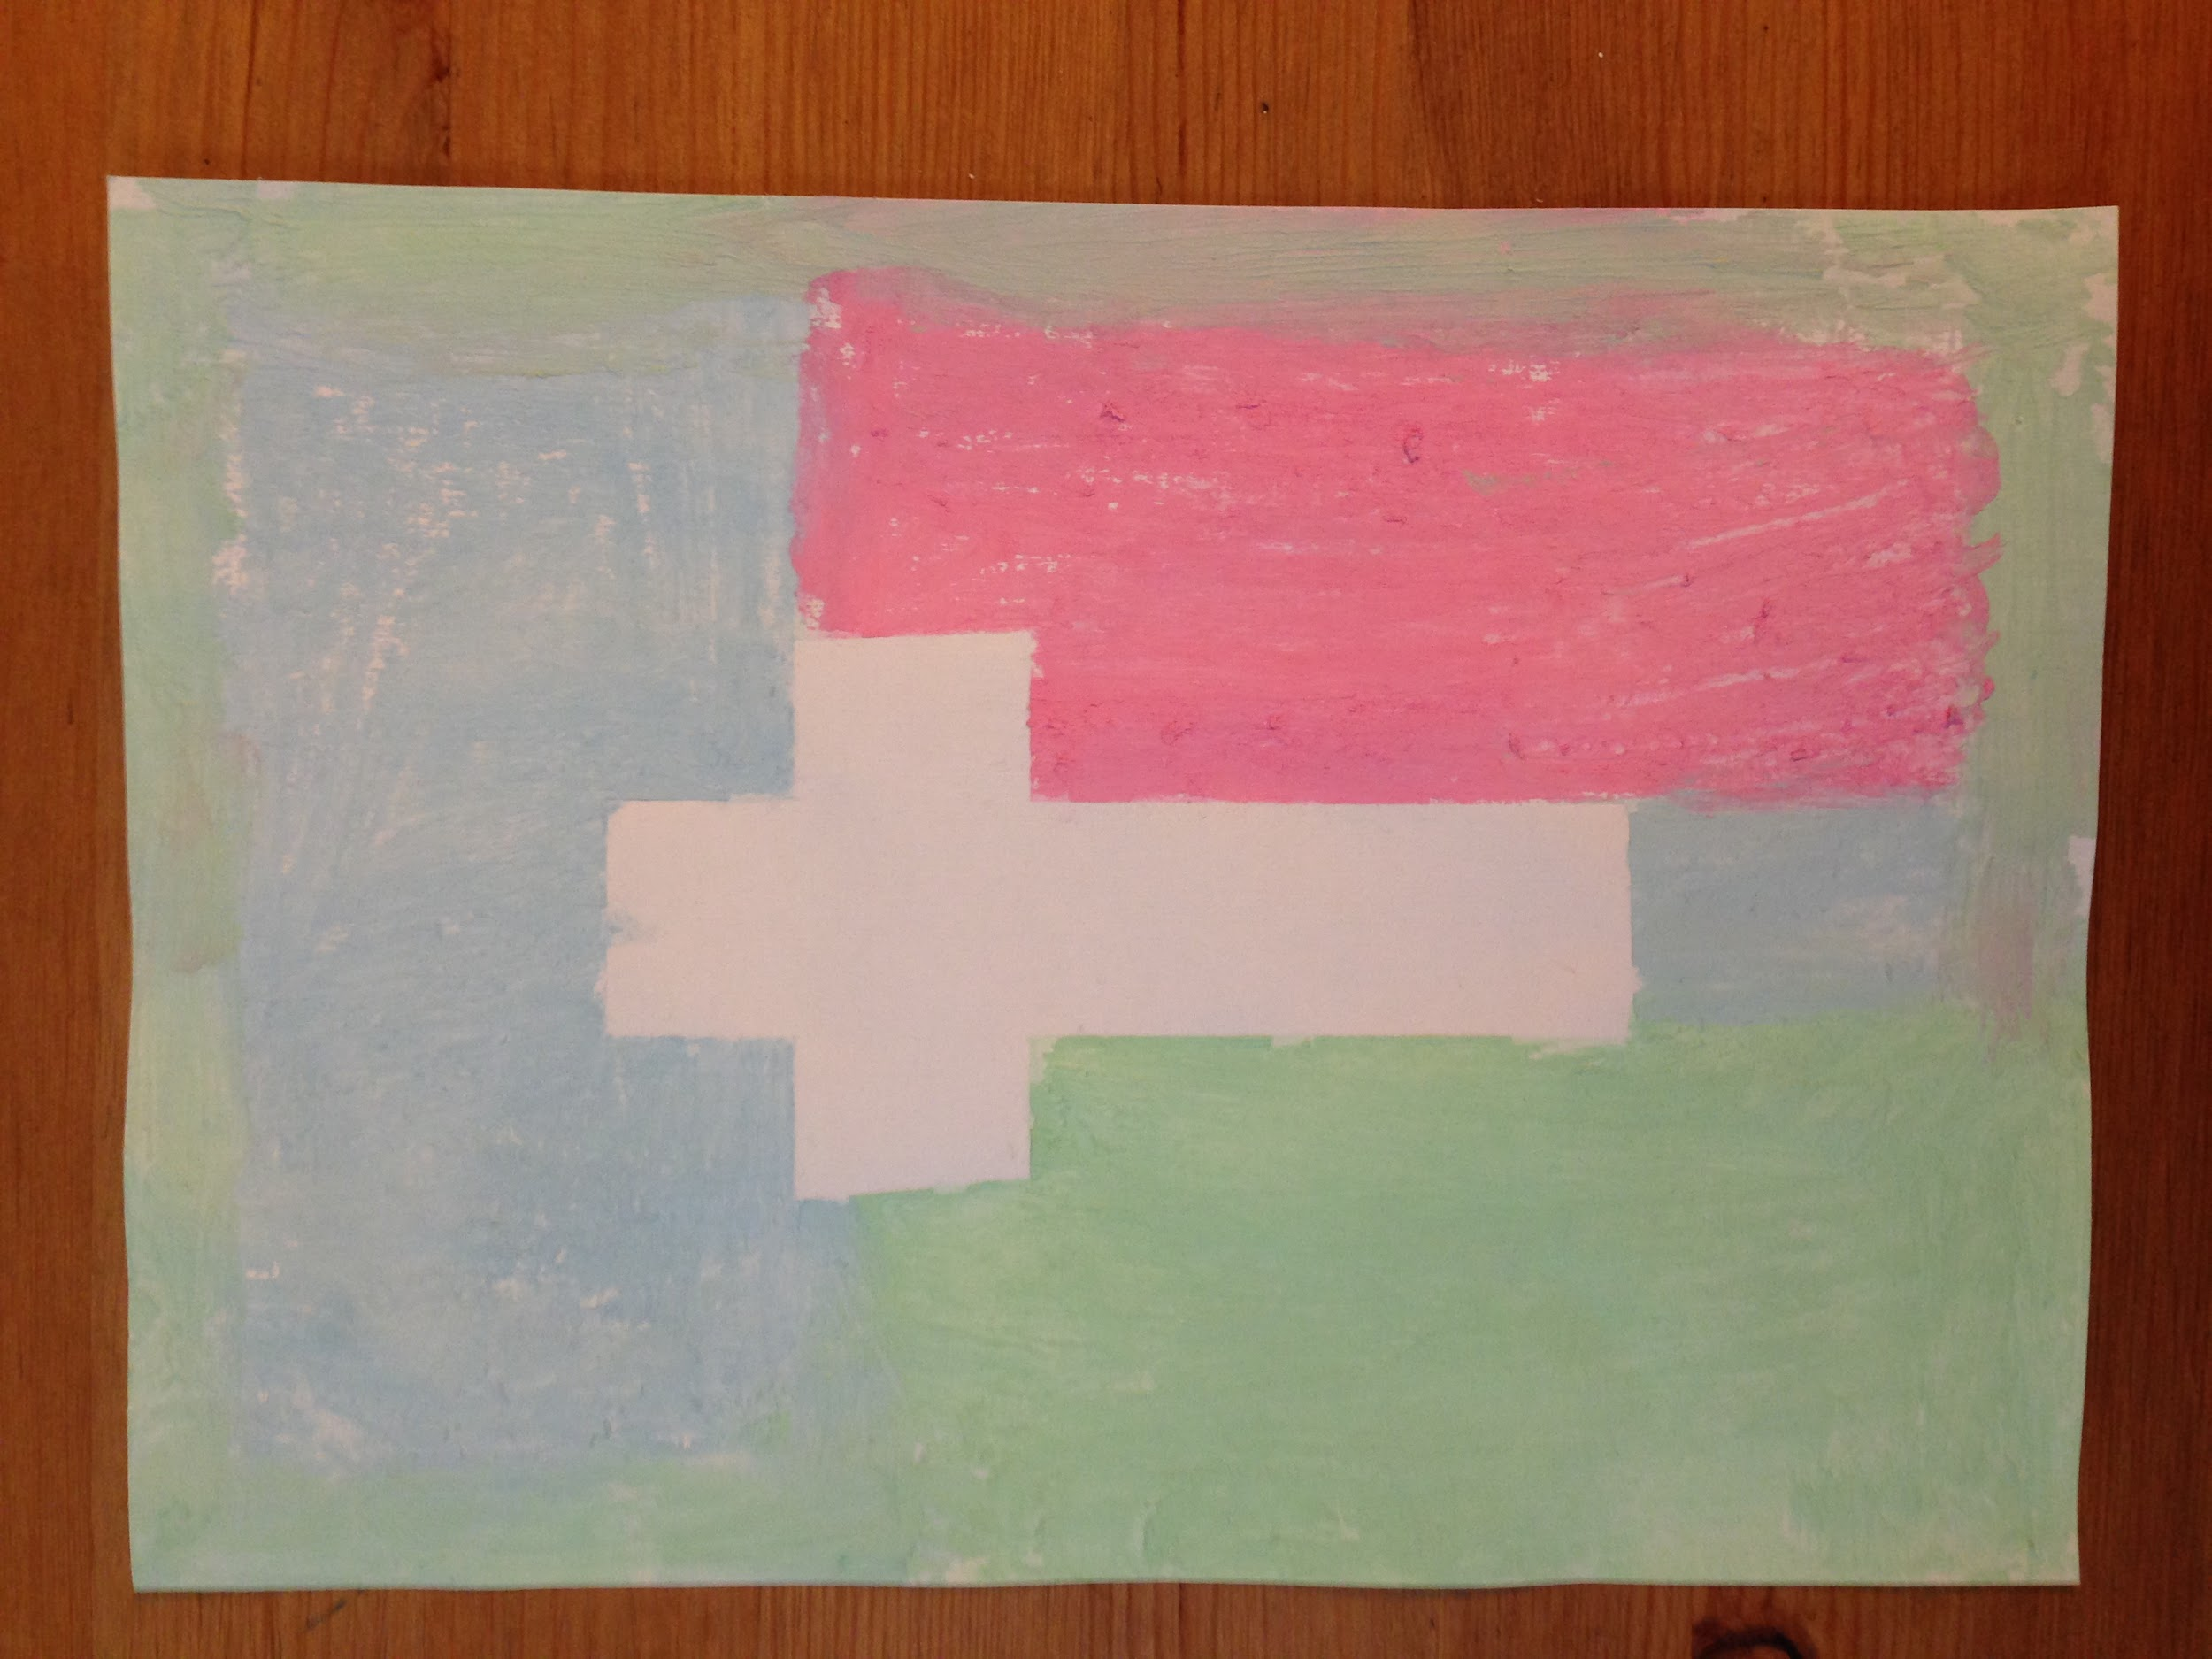

Supplies:
- Chalk
- Bowls
- Water
- Stiff Paper
- Masking Tape
- Newspaper
- Sharpies

How to Create the Crosses:
The technique that this craft is using is wet chalk. When chalk is wet and then colored with, it works similar to paint. It is fun to use and creates a cool effect. When making this craft, take a piece of stiff paper. Take two strips of masking tape, one longer than the other. One strip is the vertical part of the cross and the other is the horizontal part. Put these two piece of tape in the center of the paper in the shape of a cross. Now take chalk and color on the paper. Color everywhere and anywhere, even over the tape. When you are done, set it aside to dry. Once it has dried, peel the tape off.

Preparation:
- Have bowls of water with red, orange, and yellow chalk in them already on the table
  - In order for the wet chalk to work, the chalk must soak in the water for a while
- Have the newspaper spread out on the table
- Set up a drying station

Instructions for when the group arrives:
- Welcome the group back to VBS
- Explain the craft that they will be creating today and show the sample that is provided
- Ask them what the theme is for the day (God forgives us)
  - They might not know or remember the theme yet so if they don’t get it, please remind them
- Then tell them briefly how Jesus died on the cross for our sins and how He was resurrected from the dead.
  - Again, some groups may not have gone to Bible Story yet. Please just give a brief explanation of this.
- Hand out a piece of paper and a sharpie to each of the children
- Have them write their name on the back of the paper
  - You may need to help some of them with this step
- Go around and hand out ripped tape to the children
  - Let them decide where to put it on the paper and help them put it on
- Let them color with the chalk
- When they are done, take the paper and put it on the drying station
- When the paper is dry, peel off the tape
  - This step can be done after the group leaves

Cleanup:
- At the end of the day please:
  - Dump out the bowls of water and throw out the bowls
  - Put the chalk back (the chalk can still be used again)
  - Throw out all the garbage
  - Clean up or put away supplies you don’t need for the rest of the week
  - Wipe down the table

