Day 4 Elementary Craft
Paper Plate Crosses

Introduction for the Station Leader:
Hello again! Welcome back! We are already on Day 4 of VBS. Today’s theme is God forgives us. This is shown through today’s Bible stories. The children will be covering two stories today. The Bible stories are the Passion and the Resurrection. Jesus dies on the cross to forgive our sins, and on the third day, He rises from the dead. These stories demonstrate that God forgives us.
When people rode out West, they usually rode out in a group. Also, when the people finally settled, they lived in small towns. In both these situations, the people only had who was around them to rely on. Also, many times there would be disagreements which is what happens with any group of people. The settlers had to learn to forgive each other so they could work together to survive. Forgiveness helped them start a new life.
Today’s craft illustrates the Passion of Jesus Christ. The most iconic symbol of the Passion is the cross. The craft today is three crosses on a black piece of paper stapled onto a sunset paper plate. This is a very fun and easy craft to do that uses some materials and techniques that some may have never thought of doing before. It is a reminder that God forgives us.

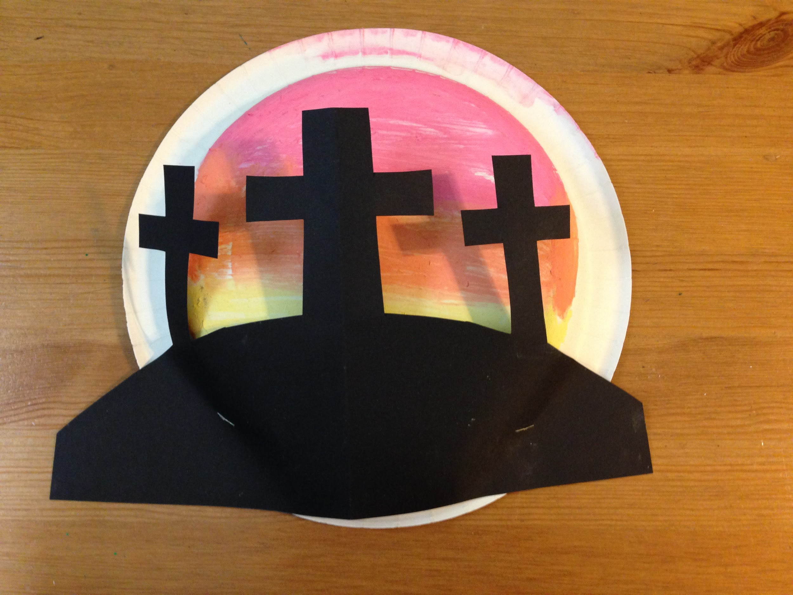

Supplies:
- White Paper Plates
- Black Construction Paper
- Bowls
- Chalk (red, yellow, and orange)
- Stapler
- Scissors
- Sharpies
- Water

How to Create the Paper Plate Crosses:
The technique that this craft is using is wet chalk. When chalk is wet and then colored with, it works similar to paint. It is fun to use and creates a cool effect. When making this craft, take a paper plate, and flip it over so the back is facing you. Paint a sunset on it with the wet chalk. It doesn’t have to be like the sample at all. Once you are done, set that aside. Take a black piece of paper, and cut a hill and three crosses out of it. You can refer to the sample if you need help. Then take the paper crosses and staple them to the back of the plate. Set aside on a drying station to continue drying.

Preparation:
- Have bowls of water with red, orange, and yellow chalk in them already on the table
  - In order for the wet chalk to work, the chalk must soak in the water for a while
- Have scissors on the table
- Have black construction paper on the table
- Set up a drying station

Instructions for when the group arrives:
- Welcome the group back to VBS
- Explain the craft that they will be creating today and show the sample that is provided
- Ask them what the theme is for the day (God forgives us)
  - They might not know or remember the theme yet so if they don’t get it, please remind them
- Then tell them briefly how Jesus died on the cross for our sins and how He was resurrected from the dead.
  - Again, some groups may not have gone to Bible Story yet. Please just give a brief explanation of this.
- Hand out paper plates and sharpies and have them write their names on the front (the side that you usually eat off)
- Let them color the sunset with the wet chalk
- When they are done, have them grab a piece of black construction paper and scissors and cut out the crosses
- When they are done with that, you must staple the crosses to the paper plate
- Set the finished craft on the drying station

Cleanup:
- At the end of the day please:
  - Dump out the bowls of water and throw out the bowls
  - Put the chalk back (the chalk can still be used again)
  - Throw out all the garbage
  - Clean up or put away supplies you don’t need for the rest of the week
  - Wipe down the table

