Day 3 Preschool Craft
Magnet Teepee

Introduction for Station Leader:
Welcome back to Day 3 of VBS! Today’s theme is God provides for us. This concept is shown many times throughout the Bible in a number of Bible stories. Today’s Bible story is of Elijah and the Widow at Zarephath. In this story, God sends Elijah to Zarephath to find a widow that will provide him with food. He finds the widow, but she says she only has enough oil and flour for one more meal. Elijah tells her to cook that, and God will make sure that the oil and flour never runs outs. The widow does as Elijah says, and the oil and flour never runs out. God provides food.
God not only provides food but also shelter and supplies. In the West, the settlers came out with a few items and had to acquire the rest. They had to build their own shelters and find their own food and supplies. All these items were provided in the wild for their use to survive. This also applies to Native Americans. The land also provided all the materials they needed. Everything was provided.
Today’s craft is making magnet teepees. One of the most famous shelters in the West was the Native American teepee. We are making teepees to show that God doesn’t only provide food but also shelter among other things. These teepees are cool to make and show this idea.

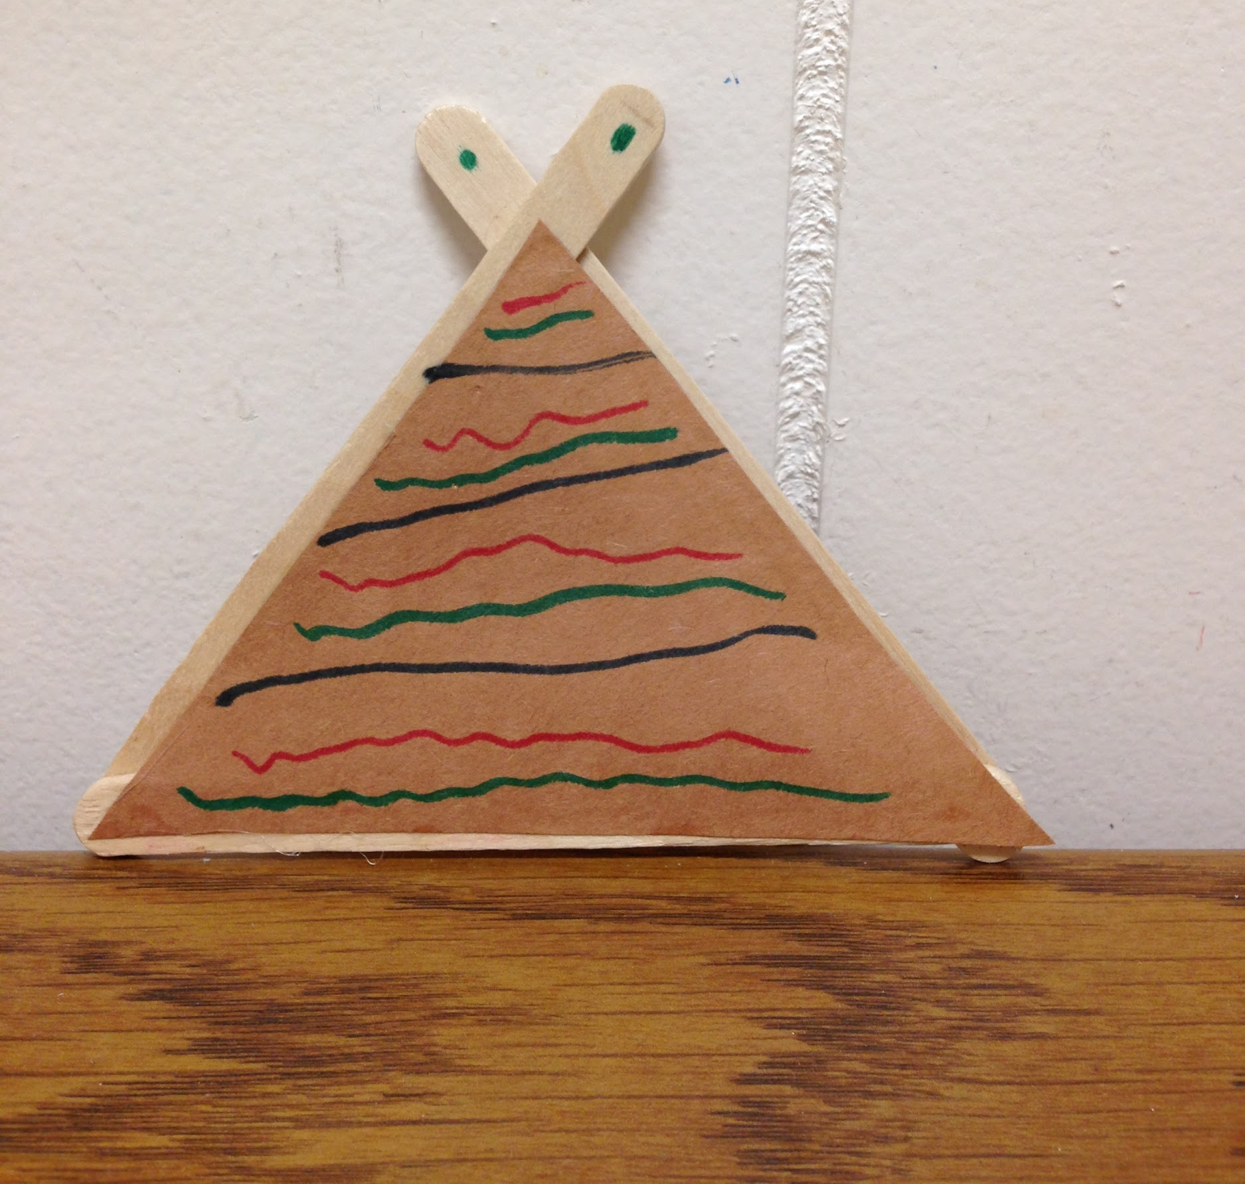
Supplies:
- Popsicle Sticks
- Brown Construction Paper
- Pencils
- Scissors
- Markers
- Magnets
- Elmer’s Glue (or any other type of wet glue)
- Triangle Templates

How to create the teepee:
To begin, take a piece of brown construction paper and a template. Trace the template on the paper and cut out the triangle. On one side of the triangle, color it with the markers. Once that is done, take three popsicle sticks and position them to make a triangle that will fit your triangle piece. Glue the popsicle sticks together. Then, take your triangle and glue it on top of the popsicle sticks. Take your magnets and put them on the back of the popsicle sticks.

Preparation:
- Have markers and pencils on the table
- Have the sample teepee on the table
- Set up a drying station

Instructions for when the group arrives:
- Welcome the group back to Day 3 of VBS
- Explain what the craft is today and show the sample
- Ask them what the theme is for the day (God protects us)
  - They might not know or remember the theme yet so if they don’t get it, please remind them
- Then tell them briefly how God provided food for Elijah and the Native Americans were provided shelter through teepees.
  - Again, some groups may not have gone to Bible Story yet. Please just give a brief explanation of this.
- Hand out a piece of brown construction paper and a template to each child
- Have them trace and cut out a triangle that is roughly the same size as the template
  - You made need to help them with cutting
- Have the children write their name on one side of the triangle and color it on the opposite side
- When they are finished coloring, have them take three popsicle sticks and position them into a triangle
  - You may have to help them with this as well
- Help the child glue the popsicle sticks together and glue the triangle on top
- Have the children put the magnets on the back of the popsicle sticks
- Put the teepee on the drying rack

Clean up:
- At the end of the day please:
  - Clean up or put away supplies you don’t need for the rest of the week
  - Clean up any paper that is on the table or on the floor
  - Wipe down the table

