Day 3 Elementary Craft
Teepee

Introduction for Station Leader:
Welcome back to Day 3 of VBS! Today’s theme is God provides for us. This concept is shown many times throughout the Bible in a number of Bible stories. Today’s Bible story is of Elijah and the Widow at Zarephath. In this story, God sends Elijah to Zarephath to find a widow that will provide him with food. He finds the widow, but she says she only has enough oil and flour for one more meal. Elijah tells her to cook that, and God will make sure that the oil and flour never runs outs. The widow does as Elijah says, and the oil and flour never runs out. God provides food.
God not only provides food but also shelter and supplies. In the West, the settlers came out with a few items and had to acquire the rest. They had to build their own shelters and find their own food and supplies. All these items were provided in the wild for their use to survive. This also applies to Native Americans. The land also provided all the materials they needed. Everything was provided.
Today’s craft is making three dimensional teepees. One of the most famous shelters in the West was the Native American teepee. We are making teepees to show that God doesn’t only provide food but also shelter among other things. These teepees are cool to make and show this idea.

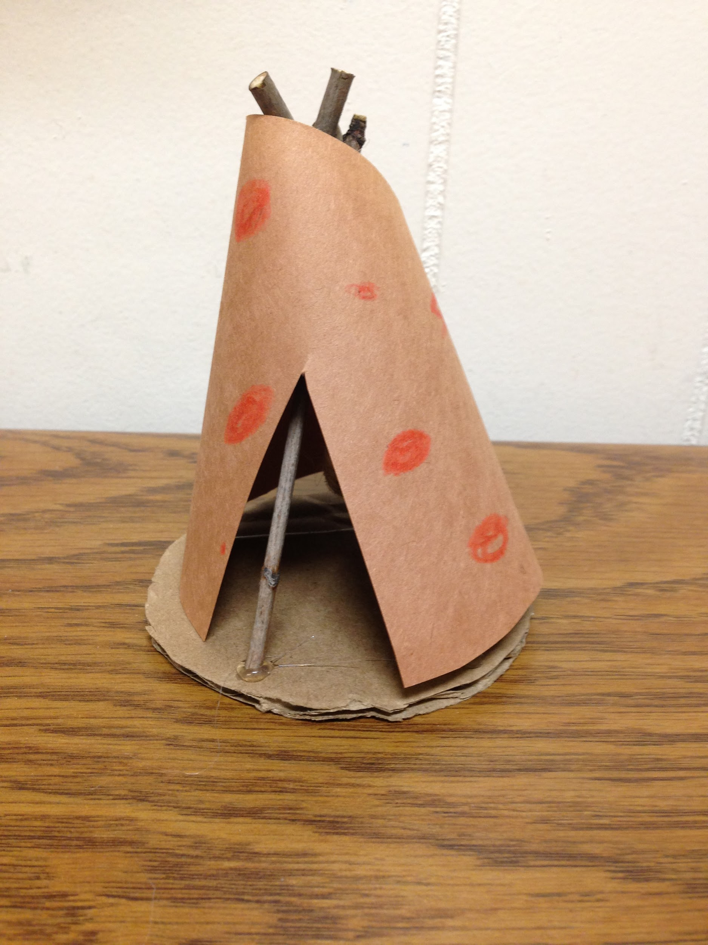
Supplies:
- Cardboard circles
- Scissors
- String
- Sticks/Popsicle Sticks
- Tan construction paper
- Teepee Cover Templates
- Crayons
- Markers
- Hot glue gun
- Scotch Tape
- Wax paper
- Sharpies

How to create the teepee:
Take a cardboard circle and four sticks. With a hot glue gun, put four dots of glue on the cardboard. Put one end of each stick on a dot of glue. Make sure the sticks face upwards and the tops come together in the middle. The glue should dry very quickly. Tie a piece of string around the top of the sticks. This is the skeleton of the teepee.
Take a piece of tan construction paper, trace it with the template, and cut it out. Color it with the markers and crayons. Once you are done coloring, take the paper and fold it around the sticks. Fit it how you like then tape the two sides together. Take a pair of scissors and cut a triangle on one part of the paper.

Preparation:
- Have the template, scissors, markers, crayons, and scotch tape
- Have the hot glue gun plugged in on a piece of waxed paper far away from the table
  - This is so it can warm up
- Have the string and a pair of scissors in the same spot as the hot glue gun
- Pre-cut pieces of the string

Instructions for when the group arrives:
- Welcome the group back to Day 3 of VBS
- Explain what the craft is today and show the sample
- Ask them what the theme is for the day (God protects us)
  - They might not know or remember the theme yet so if they don’t get it, please remind them
- Then tell them briefly how God provided food for Elijah and the Native Americans were provided shelter through teepees.
  - Again, some groups may not have gone to Bible Story yet. Please just give a brief explanation of this.
- Have each child grab a cardboard circle and a piece of construction paper
- Have the write their name on the bottom of the circle
- Have each child grab four sticks from on the table
- Have them take a template, trace it on the paper, and cut it out
- As they are doing this,
  - Call them over one at a time with their cardboard circles and sticks
  - Put four dots on the cardboard and glue the sticks
  - Tie the string on top of the strings
- After the skeleton of the teepee is glued have them tape the paper on
- Have them cut a triangle in a part of the teepee

Clean up:
- At the end of the day please:
  - Put away the glue gun
  - Clean up or put away supplies you don’t need for the rest of the week
  - Wipe down the table

